Digitalizing Coursebooks? Why Not

Lu’lu’ul Jannah
luuljannah0@gmail.com
STKIP PGRI Trenggalek

Yudi Basuki
jude.q13@gmail.com
STKIP PGRI Trenggalek

ABSTRACT
As a matter of fact, in today digital era, the advancement of ICT (Information and Communication Technology) has shifted teaching-learning paradigm rapidly. The objective of the research is to develop a digital vocabulary coursebook (buku ajar) for Students of English language education department which can be applied on the smartphone. It is digitalized by using Adobe Flash CS6 Professional software with APK format. The smartphone that supports the application is android version 1.5 (cupcake) or above. The researchers design an educational R&D research approach aimed at developing educational products, like curriculum, syllabus, textbooks, instructional media, etc. The subject of this research is the second semester of English language education department students of STKIP PGRI Trenggalek 2018/2019 academic year. The instruments used in this research are a questionnaire, interview, and observation. Those instruments of the data were analyzed in two different ways. The data collected by questionnaire was analyzed quantitatively, and data collected by observation and interview were analyzed qualitatively. Research findings show that the developed product which was based on students’ needs, the recent theory of vocabulary, R&D, digitalizing and vocabulary coursebook which was also developed in five steps development resulted good responses from students in TLP of vocabulary subject in English language Education department. Mostly students agree that the digital book applied on their smart phone is indispensable necessity for today TLP which they may access it anywhere and anytime with ease. Besides, the product once also proves that digital material is more motivating, engaging and fun than the conventional one.

Keywords: Coursebook, Digital, Vocabulary
INTRODUCTION
Byars (2015) argues that Book is the foundation of learning from people's lives. It has the purpose to deliver information. Meanwhile, Surahman in Fikriyati (2014) mentioned there are four kinds of book. They are sourcebook, riding book, handbook, and coursebook (Buku Ajar). Hence, the book is the foundation of learning from people's lives in the form of printed sheets of paper fastened together in a cover. It is divided into several kinds of book, namely sourcebook, riding book, handbook, references book, monograph book, dictates, module, and coursebook (Buku Ajar).
As a matter of fact, in today digital era, the advancement of ICT (Information and Communication Technology) has shifted the teaching-learning paradigm rapidly, Basuki & Hidayati (2019). Further, Jean (2009) argues, "The ICT revolution changing all models and patterns of our lives and hence bound to lead to dramatic changes in education". In addition, Rodriguez et al (2010) state that everything has developed, notebooks and pens are giving way to computers, blackboard to interactive whiteboards, and textbook to digital textbook.
In contrary to the education revolution mentioned above, English language education department as one of the majorities in STKIP PGRI Trenggalek has published some books. These books are from the outcomes of the lectures' researches. There are “Televocabot” by Yudi Basuki and M. Posyidin, “Buku Ajar Vocabulary 2” by Yudi Basuki, M.Pd. Astried Damayanti, M.Pd. Sri Utami Dewi, M.Pd., “Desaku yang Kucinta” by Yudi Basuki, M.Pd., Ari Metalin Ika Puspita, M.Pd., Drs. Agus Budi Santosa, M.Pd., Dr. Yoppy Dwi Purnomo, M.Pd., Dr. Ishaq Nuriadin, M.Pd. “Dictionary of English-Indonesian Terminology: Health & Medical Edition” by Fahrudin and Yudi Basuki, and the next book is “Dictionary of English-Indonesian Terminology: ICT & Trade Edition” by Yudi Basuki and Fahrudin. Unfortunately, the books are still in printed book model, and they have not been digitalized yet.
Considering the importance of technology inclusion in education and the condition of books mentioned above. This research is aimed at digitalizing one of the books, namely vocabulary 2 course book (Buku Ajar) for English language students of STKIP PGRI Trenggalek. Meanwhile this research tries to answer the following research problem; “How to digitalize vocabulary 2 coursebook (Buku Ajar) for the students of English language education department?”
The product of this research is a digital vocabulary 2 coursebook which is developed in the software form with APK format file flash. This product requires Adobe Air as a plug-in. The smartphone that supports application is android with version 1.5 (cupcake) or above. It is digitalized by using Adobe Flash CS6 Professional. Adobe Flash CS6 Professional is one of PC application that can be installed on PC with the minimum specification, processor Intel Pentium 4, Ram 256mb, Harddisk 20 GB, operating system Windows XP or above. The size of digital vocabulary coursebook (Buku Ajar) is 27mb. Further, there are five features of the coursebook (Buku Ajar) they are; instructional analysis, mind map, lesson review, first thing first, and summary. For the chapter, there are seven chapters in this coursebook (Buku Ajar) they are, chapter I (word partners), chapter II (word stalks), chapter III (word in comparison), chapter IV (word to determine & the punctuations), chapter V (word noun in phrase), chapter VI (word in mistake), chapter VII (words with figurative meaning). Each chapter is divided into three contents; they are the introduction, presentation, and closing. The introduction includes of course description, relevancy, competence, and indicator, learning directions. The presentation includes content elaboration and summary. The last is closing; includes summative test and students’ feedback.
Reviewing related literatures, vocabulary can be defined as "words we must know to communicate effectively" Neuman & Dawyer in Alqhtani (2015). Then, Hornby in Alqahtani, (2015) stated: "vocabulary is the total number of words in a language; vocabulary is a list of words with their meaning". While, In language learning, choosing the vocabulary materials must be done selectively, Basuki, et. al. (2018). Thus vocabulary is the total number of words in a language with their meanings. It is an important thing for those who learn a new language. To teach vocabulary, the material must be chosen selectively in order to make students able to communicate effectively.
Further, Book is defined as "Number of printed sheets of paper fastened together in a cover, Evison (2008). While Byars (2015) argues, "Book is an integral part of people's lives. They provide the foundation of learning from an early age till continue to grow with people throughout their adult lives". Meanwhile, Surahman in Fikriyati (2014) states that there are four kinds of book; sourcebook, riding book, handbook, and coursebook (Buku Ajar). Additionally, Nurdiyansyah (2016) mentions several kinds of books in education; reference book, coursebook, monograph book, dictates, and module (https://www.duniadosen.com/buku-referensi-m) accessed on March, 8th 2019, at 11.33 a.m. Accordingly, book is a foundation of learning; it is formed in paper's printed sheet that has some types, namely sourcebook, reading a book, handbook, references book, monograph book, dictates, module, and coursebook (Buku Ajar).
To discuss further, the term “digital” in this research means the using an electronic system that uses the number 1 and 0 to record sound and store information. Alan, Evison (2008). Then, "the widespread use of digital technologies is type form of computer, laptops, tablets, smartphones, mobile phones, and so on," Kapur (2018). Meanwhile, Wikramanayake (2014) states that "since early 1960s educators and computer scientist began using computers for teaching purposes". Similarly, Hashim (2018) states that in the digital era, technology becomes a crucial part of education. Education is already starting to move their way with the emergence of current technology. With the help of technology, the process of teaching and learning is no longer restricted to the classroom. In short, Digital is a technology that uses an electronic system (number 1 and 0) to record sound and store information; it is in the form of computer, laptops, tablets, smartphones, mobile phones, and so on. And in digital education era, digitalization is a crucial part that educators and computer scientist began using computers for teaching purposes.

METHOD
The research method used in this research is research and development (R&D). According to Basuki (2017), Research and Development (R & D) is “a research carried out by educational practitioners to get findings that is beneficial to design and develop new products/ procedures/ materials such as curriculum, syllabus, textbooks, instructional media, etc."
Meanwhile, the research procedure in this research (adapted from Latief in Basuki, 2017) consists of five steps, they are need analysis, studying recent theories of education product development, developing the educational product, validating the product to expert, and field-testing the product.
Figure 1. The procedure of development (adapted from Latief in Basuki, 2017)
- Needs analysis
- Giving questionnaire to students and lecturers of vocabulary course.
- Analyzing data from the questionnaire.
- Studying recent theories of educational product development.
- Studying Theory of R & D
- Studying Theory of vocabulary and digital
- Studying the theory of digital vocabulary coursebook.

- Validating the product to expert
- Giving the trial to the expert
- Interviewing the expert
- Getting validation of the product

3. Developing the educational product
- Choosing theme.
- Developing the product

- Field-Testing the product
- Trying the product to the students and lecturer of vocabulary course.
- Observing the studying and learning process by using the product.
- Giving a questionnaire to the user to get the feedback.

Meanwhile, Sugiyono (2015) explains that population is a region in general that consist of object/subject with characteristics that determined by the researcher to be studied and then define conclusion. Thus the population is not an only human being, but also everything around which has characteristic. In this research, the population is the English language students of STKIP PGRI Trenggalek that consists of 72 students.
The instruments used in this research are a questionnaire, interview, and observation. The first instrument is a questionnaire, and it is one of the data collection method, which is done by giving a set of question or written statement to the respondent to be answered, Sugiyono (2014). In this research, the questionnaire is implemented twice; in need of analysis and field-testing product of the research steps. The next instrument is an interview, and it is an activity done to get information directly by expressing the questions to the respondents/self-report or at least on self-knowledge and self believe Sugiyono (2010). In this research, the researchers use interview to get the expert's evaluation in validating the product to the expert step. The last instrument used in this research is observation; it is one of the data collection methods which has specific characteristics when compared with other techniques. Observation is not limited to people, but also other natural objects, Sugiyono (2010). In this research, the researcher uses observation in a try-out field testing step to know the applicability of developed product in real vocabulary learning and teaching.

The data analysis of this research uses qualitative and quantitative analysis technique. The researcher uses the Likert scale to analyze the data of the students' questionnaire on need analysis and evaluating the process. Sugiyono (2010) explains that the Likert scale is the scale used to measure someone's or group's opinion about research variable. Each item in the scale is scored as follow:
Strongly Agree (SA) : 5 Agree (A) : 4
Neutral (N) : 3 Disagree (D) : 2
Strongly Disagree (SD): 1
Calculating the score range:
Maximum Score = 24 x 5 = 120 x 28 = 3360
Minimum Scores = 24 x 1 = 24 x 28 = 672
Score Range = 3360 – 672 = 2688
Calculating the width class interval (P)
P = R/K = 3360/5 = 672

Table 1. Score Interpretation
Score | Score Range | Interpretation
3360 | 3360 - 3025 | Strongly Agree
2688 | 3024 - 2353 | Agree
2016 | 2352 - 1681 | Neutral
1344 | 1681 - 1009 | Disagree
672 | 1008 - 672 | Strongly Disagree

Figure 2. Continuum Diagram of the interpretation of the scores
3360 2688 2016 1344 672
Strongly agree Agree Neutral Disagree Strongly disagree
Meanwhile, the data of interview and observation are analyzed descriptively or qualitatively. It means that data are served in detail explanation to get a conclusion based on the data.

FINDINGS AND DISCUSSION
The data reduction that leads to the finding of the research is elaborated as the following;

Finding on Need Analysis

Table 2. Finding on the Students Need Analysis
Finding on Students’ Need Analysis Questionnaire | - Nearly 60% of students agree that digital book is better than a printed book
 | - Nearly 78% of students agree that the digital book is more effective than a printed book.
 | - Nearly 45% of students agree that it is nice to bring the book anywhere.
 | - Nearly 48% of students agree that a digital book in PDF form is interesting.
 | - Nearly 35% of students agree that material in PowerPoint is interesting.
 | - Nearly 65% of students agree that digital book with animations is attractive.
 | - Nearly 20% of students agree that material in the form of soft file is better than a hard file.
 | - Nearly 81% of students agree that it is important to have an electronic material for vocabulary coursebook.
 | - Nearly 74% of students agree that digital book material for vocabulary is motivating.
 | - Nearly 70% of students agree that learning with a complex digital book (audio-visual) is enjoyable.
 | - Nearly 67% of students agree learning with complex media (interactive-audio-visual) is enjoyable.
 | - Nearly 81% of students agree that it is simple to use digital book.
 | - Every student agree that colorful digital book is enjoyable.
 | - Nearly 78% of students agree that digital book with an audio feature is helpful.
 | - Nearly 50% of students agree that digital book must have to the point explanation.
 | - Nearly 40% of students agree that structured digital book is easy to understand
 | - Nearly 81% of students agree that digital book must have complete content.
 | - Nearly 78% of students agree that digital book with clear material is needed.
 | - Every student agrees that digital book must be up to date.
 | - Every student agrees that digital book must have a clear explanation.
 | - Nearly 96% of students agree that digital book with affordable price is needed.
 | - Nearly 50% of students agree that small size digital book is required.
 | - Nearly 81% of students agree that the digital book is easy to operate.
 | - Every student agrees that digital book of vocabulary lesson is needed.
2550

3360 2688 2016 1344 672
Strongly agree Agree Neutral Disagree Strongly disagree

Figure 3. Continuum Diagram of Need Analysis Total Score

Finding on Material Development

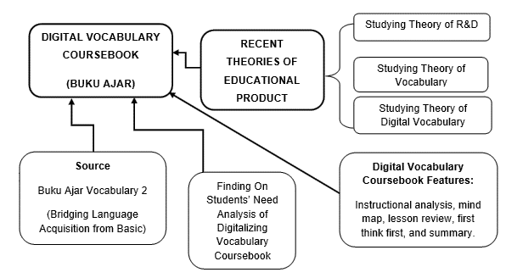
Figure 4. Finding on Material Development

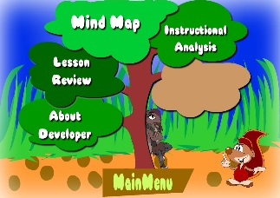
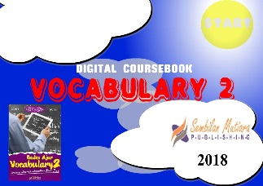
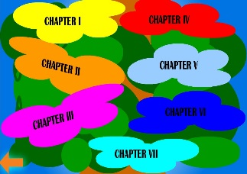
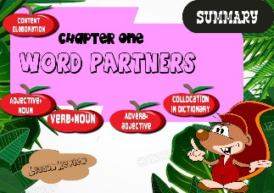

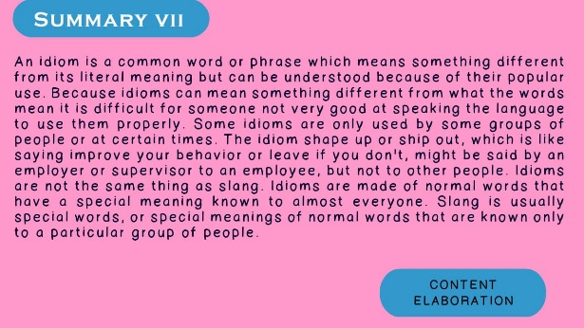
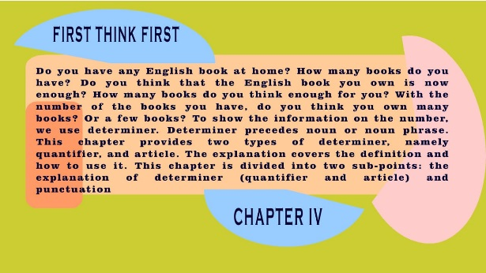

Finding on Expert Validation
After the product has been developed completely, the researchers consulted the product to the expert of English language material development to give evaluation and suggestion in order to be an acceptable and approved product.
The expert argued that the product is good enough but needs revision. As a result, he evaluates and recommends some suggestions; first, re-designing some of the backgrounds of the materials presented to be more contrast and colorful. Second, adding some pictures and additional illustrations to be more comprehensive materials. Third, changing the font style because it was too formal and not joyful to read. The fourth, relating all contents of the coursebook. The last, giving the music/back sound to make the material more attractive.

Finding on Field-Testing

Table 4. The Result of 1st Questionnaire on Field-Testing
Finding on Students’ Field Testing on 1st Questionnaire | - Nearly 64% of students convey that the cover of digital vocabulary coursebook 2 is good
 | - Nearly 78% of students convey that the layout of digital vocabulary coursebook 2 is good.
 | - Nearly 82% of students convey that the animation of digital vocabulary coursebook 2 is good.
 | - Nearly 82% of students convey that the theme of digital vocabulary coursebook 2 is good.
 | - Nearly 82% of students convey that the sound in digital vocabulary coursebook 2 is good.
 | - Nearly 46% of students convey that the effectiveness of digital vocabulary coursebook 2 is good.
 | - Nearly 50% of students convey that the style and size of the font in digital vocabulary coursebook 2 is good.
 | - Nearly 40% of students convey that the picture and the color of digital vocabulary coursebook 2 are good.
 | - Nearly 46% of students convey that material complexity in digital vocabulary coursebook 2 is good.
 | - Nearly 78% of students convey that the material organization of digital vocabulary coursebook 2 is good.
 | - Nearly 82% of students convey that the material description of digital vocabulary coursebook 2 is good.
 | - Nearly 67% of students convey that the instructional learning of digital vocabulary coursebook 2 is good.
 | - Nearly 57% of students convey that the illustration and examples are given in digital vocabulary coursebook 2 is good.
 | - Nearly 50% of students convey that this product develops the students learning motivation.
 | - Nearly 82% of students convey that this product gives the chances for students as the center of learning (SCL)
 | - Nearly 82% of students convey that this product is up to date.
 | - Nearly 78% of students convey that this product is suitable.
 | - Nearly 86% of students convey that the language style in the product is good.
 | - Nearly 71% of students convey that the punctuation in the product is good.
 | - Nearly 75% of students convey that grammar in the product is good.
 | - Nearly 86% of students convey that the spelling in the product is good.
 | - Nearly 67% of students convey that the coherence in the product is good.
 | - Nearly 82% of students convey that the word choice in the product is good.
 | - Nearly 67% of students convey that this product is easy to understand
2505

3360 2688 2016 1344 672
Strongly agree Agree Neutral Disagree Strongly disagree

Figure 5. Continuum Diagram of Field-Testing

Table 5. The Result of 2nd Questionnaire on Field-Testing
No/Item Questionnaire’s Item Most Feedback
1 | The coursebook was digitalized based on students need | Yes : 28 Respondents  No : 0 Respondent
2 | The digital book decrease dependency on lecturer | Yes : 12 Respondents  No : 16 Respondents
3 | The contents of the digital book are arranged well | Yes : 28 Respondents  No : 0 Respondents
4 | The contents of the digital book are suitable for independent and group learning | Yes : 26 Respondents  No : 2 Respondents
5 | This digital book has an attractive appearance | Yes : 20 Respondents  No : 8 Respondents
6 | The contents of the digital book are appropriate for the student level | Yes : 27 Respondents  No : 1 Respondent
7 | Topics of digital books is appropriate to the context | Yes : 27 Respondents  No : 1 Respondent
8 | Topics of the digital books are relevant | Yes : 26 Respondents  No : 2 Respondents
9 | The ability of communication can developed by using this digital book | Yes : 24 Respondents  No : 4 Respondents
10 | Material in a digital book can be caught easily | Yes : 17 Respondents  No : 11 Respondents
11 | The features of the digital book are very useful for classroom learning | Yes : 24 Respondents  No : 4 Respondents
12 | The students have time to reinforce the material with digital books | Yes : 28 Respondents  No : 0 Respondents
13 | This digital book is recommended for STKIP PGRI Trenggalek students | Yes : 28 Respondents  No : 0 Respondents
Meanwhile, based on the observation done in field-testing, the researchers found that the lecturer and students look interested while trying this product. They follow all steps given by the researchers with ease. They are able to operate this product efficiently on their smart phones. Also, this product gives a chance to the teacher and students to make a question and answer interaction.
Discussion
Given the research finding explained above, the discussion of the findings of this research is summarized as the following:
Table 6. The Discussion of the Research Finding
Digital  Vocabulary Coursebook for English language students of STKIP PGRI Trenggalek | Discussions
 | Regarding to the content material of this research they are; instructional analysis, mind map, lesson review, first think first, and summary, that was in line with Basuki, et. al. (2018) who argue that “Coursebook (Buku Ajar) is a handbook for a course written by experts in related fields.
 | Regarding the material development steps on this research that took five steps was in line with the expert explanation they are; need analysis, studying recent theories of education product development, developing the educational product, validating the product to expert and field-testing the product. Latief in Basuki (2017) stated that there are five procedures of development. They are need analysis, studying recent theories of education product development, developing the educational product, validating the product to expert, and field-testing the product.
 | Regarding the form of product (Digital Form) on this research was in line with expert explanation, Alan, Evison (2018) Digital mean using an electronic system that uses the number 1 and 0 to record sound and store information.

CONCLUSION AND SUGGESTION
The product of a digital vocabulary coursebook (buku ajar) was successfully developed with five steps development which was based on the result of need analysis, studying the theory of R&D, studying the theory of vocabulary, studying the theory of digital coursebook, evaluation/suggestion from the expert and field testing of the product.
Based on the continuum diagram of need analysis with the total score 2550, it could be concluded that the need of digital book in this digital era is indispensable necessities. Meanwhile, as the findings of studying recent theories (R&D, vocabulary, digital coursebook), it was proved that all theory taken in this research is true and has been scientifically tested and applied. Then, from the expert judgement, it was found that the developed product is adequate to be implemented for the TLP purposes. More importantly, the result of field testing to the real TLP in the classroom proved that the product is applicable, interesting, challenging and motivating. Thus, this research has been able to answer the research question which states; how to develop digital vocabulary 2 coursebook (Buku Ajar) for students of English language education department? And also has been able to achieve the objective of the research which is to develop a digital vocabulary course book for Students of English language education department.
Regarding to the description above, here are some suggestion for people who may find benefit of this research. The first is for the teachers and lecturers who have their own coursebook of their subject it is better to digitalize their conventional books; for it can help themselves and their students to have a better and more mutual TLP. The second is for the students learning English; it is suggested to use this product (digital vocabulary coursebook) to make their own study motivating and fun. The last is for the next researchers who may use the research findings of this research as the information and reference for their next research.

REFERENCES
Alan, Evison. (2008). Oxford learner’s pocket dictionary. New York, Oxford University Press
Alqahtani, Mofareh. (2015). The Important of Vocabulary in Language Learning and How to be Taught. 3 (2) 21-34
Basuki, Yudi. (2017). The Requisite Vocabulary 1 Material for College Students of STKIP – PGRI Trenggalek. Jurnal Pendidikan Dewantara. Vol 3 No. 1 (2017), (Online: http://journal.stkippgritrenggalek.ac.id/index.php/kid/article/view/81/43)
Basuki, Y., A. Damayanti & S. U., Dewi. (2018). Vocabulary Coursebook for EFL Learners of Higher Education in Indonesia. International Journal of Education and Literacy Studies. Vol 6 No. 4 (2018), (Online: http://www.journals.aiac.org.au/index.php/IJELS/article/view/4912)
Basuki, Yudi & Hidayati, Nurmala Y. (2019). Kahoot! Or Quizizz: the Students’ Perspective. Proceedings of the 3rd English Language and Literature International Conference, ELLiC. EAI, July (2019). (Online: https://eudl.eu/doi/10.4108/eai.27-4-2019.2285331 )
Byars, Mikayla, Nicole. (2015). Printed Books versus Digital Books. Faculty of the Graphic Communication Department California Polytechnic State University.
Fikriyati, Hilda. (2013). Pengembangan Buku Teks Ilmu Pengetahuan Sosial (IPS) SMP Kurikukulum, Universitas Negeri Semarang

Hashim, Harwati (2018), Application of Technology in the digital era education. 1(2)1-5
Underwood, Jean. (2009). The Impact of Digital Technology. Becta leading next generation learning. 1-25
Nurdiyansyah, Beni. (2016). Buku Referensi dan Buku Ajar Apa Saja Bedanya (Online), (https://www.duniadosen.com/buku-referensi-m) accessed on March, 8th 2019
Rodriguez, J.R. (2015). Digital Text Books Whats New?. Universidade de Santiago de Compostela
Soares, Fabio M.L. (2005). The Importance Of Coursebook For The Teacher Of English As A Foreign Language, Do Orientador E Da Universidade
Sugiyono. (2010). Metode Penelitian Kuantitatif, Kualitatif, dan R&D. Bandung: Alfabeta.
Sugiyono. (2014). Metode Penelitian Kuantitatif, Kualitatif, dan R&D. Bandung: Alfabeta.
Sugiyono. (2015). Metode Penelitian Kuantitatif, Kualitatif, dan R&D. Bandung: Alfabeta.

